**Input file:**

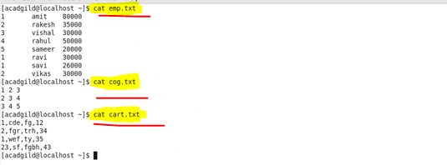

**Create and load the file emp:**

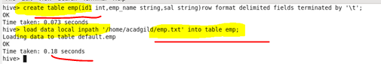

**Create and load the file cog:**

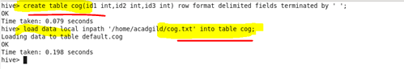

**Create and load the file cart:**

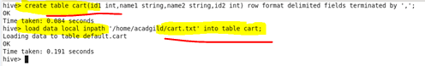

**Setting the parallel configuration in hive command line :**

**C:\Users\612926\Desktop\5.png**

**Query:**

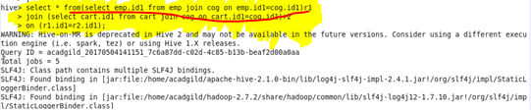

**Output:**

